Project Plan: Dbate

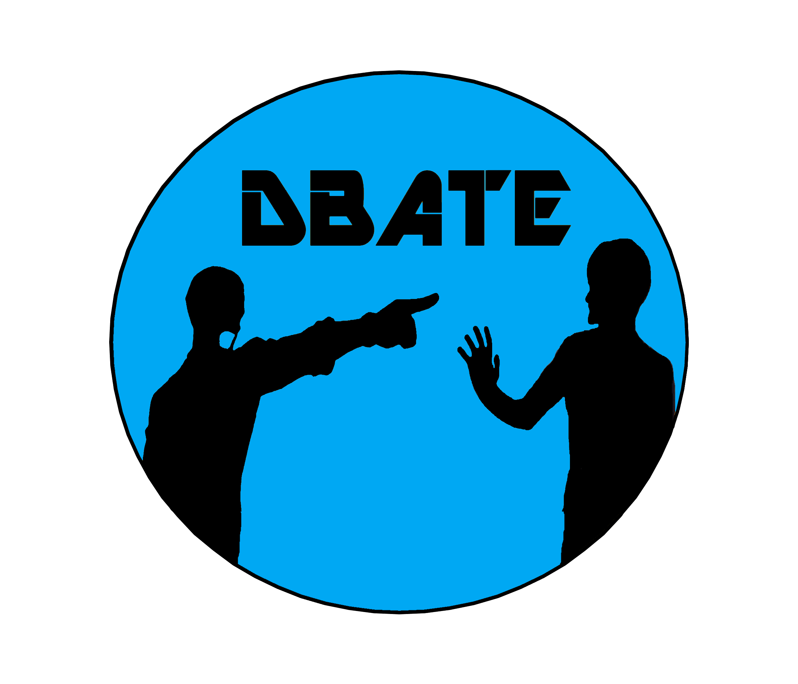

|  |  |
| --- | --- |
| Prepared By: Red Team    Group Members: | |
| Christian Flores-Rogel  Deivis Leung Liang  Luis Meza  Keanna Mae Vitug  John Cayton | 013924454 (Team Leader)  014110497  014325959  014699514  014108690 |
| Professor: Vatanak Vong  Date: February 18, 2019 | |

Table of Contents

1. **Introduction****...……………………………………………………………………2**
2. **Project Scope……………………………………………….……………………2**
3. **Resources****.……….……………………………………………….……….………3**
4. **Budget****……………………………………………………….……………………5**
5. **Time Cost Estimates****…………………………….……………….…….……….6**
6. **Timeline****……………………….………………………………….……….…….9**
7. **Roadmap****…………………………………………….……………………….…14**
8. **R****isk Management.………………………………….……………………….…15**

# Introduction

The purpose of this document is to provide detailed information and define goals that our team aims to achieve over the course of this project. In this document, our team has provided the estimated time and costs involved with this project, as well as an overview of potential risks that can affect our end product. This document is intended primarily for the development team.

The overall goal of the development team is to create a single page application called DBate that provides a platform for users to be able to develop, improve, and exercise their debating skills in an online environment. DBate will allow users to debate on randomly selected prompts in a moderated setting using a chat system that implements game-like features and functionalities. This includes the use of debate-specific roles, such as judge and debater.

# 

# Project Scope

The initial version of our web application will be a single page application that uses Web API. This version will support the latest version of Google Chrome, which includes Version 68.0 and 69.0. Our application will only be in the English language and available exclusively in North America, specifically Canada, Mexico, and the United States, for its initial release.

The role functionalities for our application will include general users, administrators, and system administrators. General users have access to the basic functionalities of the web app. In addition to inheriting rights from a general user, an administrator has access to various user management functionalities, the usage analysis dashboard, and other functionalities; whereas, a system administrator inherits the rights of an administrator and has access to all functionalities.

Our security consists of user authentication, protection of user passwords, and password resets that require a user to answer three security questions created during registration. The IP ranges in our application will include those covering the United States (1.22.56.0 to 223.197.44.239), Canada (2.17.218.0 to 217.221.47.95), and Mexico (2.20.70.0 to 216.251.76.254).

# Resources

**Project Team**

Christian Flores-Rogel

Roles

* Team Leader: As the team leader, Christian will speak on behalf of the team to the client while also making sure that everyone is on track with their tasks. As the team leader, Christian will make sure that everything is done correctly.
* Project Manager: As the project manager, Christian will make sure that the project will be delivered on time, on budget, while also meeting all the specifications needed so the client can be satisfied with the web app.
* Developer: As one of the developers in the team, Christian will aid in implementing the functionalities needed so the web app an function properly. As a developer he will focus more the back-end side of the app.

Skills

* HTML
* CSS
* C# in .NET Framework

John Cayton

Roles

* Lead Developer: As a lead developer, John will be the one in charge in developing the correct solution for the functionalities needed for the web app. He will also work closely with the project manager in order to help in finishing the project on time.

Skills

* HTML
* CSS
* C# in .NET Framework

Luis Meza

Roles

* Developer: As one of the developers in the team, Luis will help in programming the functionalities needed so the app can function properly. His main focus will be to work on the back end side of the app.
* Business Analyst: As a business Analyst, Luis will be the one in charge in converting the clients needs and wants into the requirements needed for the web app.

Skills

* HTML
* CSS
* Java

Deivis Leung Liang

Roles

* Developer: As one of the developers in the team, Deivis will help in programming the functionalities needed for the web app. Although he will aid in every aspect of the development, he will focus more on the front end side of development.
* QA: As one of the main QA’s in the team, Deivis will make sure that the app is working with minimal errors by testing the app through methods such as unit testing.

Skills

* HTML
* CSS
* C# in .NET Framework

Keanna Mae Vitug

Roles

* Developer: As one of the developers in the team. Kia will help in programming the functionalities needed for the web app. Although she will aid in every aspect of the development, she will focus more on the front end side of development.
* QA: As one of the QA’s in the team, Kia will make sure that the app is working with minimal errors by testing the app troughly.

Skills

* HTML
* CSS
* Java

# 

# 

# 

# Budget

|  |  |  |
| --- | --- | --- |
| **Resource** | **Cost** | **Purpose** |
| Cloud | $0 - $60.00 | Place where the web app will be deployed. It is used so it can be online and receive HTTP requests so the web app can run.  Our Choice is Azure which is free for one year if service limits aren’t surpassed. |
| Developers | $0.00 | Developers will be the ones in programming the web app. Since we are the developers, the cost will be minimal. |
| Miscellaneous | $0-$100 | Costs that are minor and not related to those listed above. An example of this would be printing. |
| Total Cost: $0.00 - $210.00 | | |

# Time Cost Estimates

|  |  |  |  |  |  |
| --- | --- | --- | --- | --- | --- |
| **Deliverable** | **Time Cost Total** | **Design Hours** | **Implementation Hours** | **Testing Hours** | **Description** |
| Project Plan | 29 hrs | N/A | N/A | N/A | Document that details the development stage by providing a timeline, resources, and cost |
| High Level Design Document | 58 hrs | 50 | N/A | N/A | Document that covers the high level details of the project |
| Test Plan | 42 hrs | 10 | N/A | N/A | Document that details solution validation and includes scenarios in which the web app has passed or failed |
| User Management | 86 hrs | 15 | 49 | 22 | Feature that allows administrators to control what users have access to in the app |
| Data Store Access | 53 hrs | 15 | 28 | 10 | Feature that gives users the ability to access or retrieve data stored within the database or other repository |
| User Access Control | 71 hrs | 22 | 37 | 12 | Feature that restricts features that the users can access and change within the app. |
| Scope Creep (Pwned) | 29 | 10 | 15 | 4 | This feature uses Troy Hunt’s Pwned Password to check if a password has been breached |
| Logging/  Archiving | 64 hrs | 10 | 42 | 12 | Feature that will enable the recording of warnings, errors, and key events on data that occur. |
| Usage Analysis Dashboard | 60 hrs | 15 | 33 | 12 | This feature shows statistics of the web app’s usage including when it was used, where it was accessed, and user activity. |
| Documentation | 54 hrs | N/A | N/A | N/A | Documentation on what each part of our code in the program does will be provided as well as a user manual, installation manual and other requirements of the document. |
| Chat Room | 95 hrs | 15 | 65 | 15 | Feature where teams will debate about the chosen topic using a live chat system |
| Global Setting | 56 hrs | 10 | 36 | 10 | Feature that allows hosts to modify certain aspects of the debate including role limits and time limit. |
| Game Role Functionality | 56 hrs | 10 | 31 | 15 | Feature that defines the roles that each user in a debate will be responsible for |
| Waiting Room | 53 hrs | 10 | 28 | 15 | Feature where users wait for the debate to start and allows the host to start the debate earlier if the minimum number of users is met. |
| Matchmaking | 58 hrs | 10 | 33 | 15 | Feature that allows users to join or create a debate and choose the side that they want to debate on |
| Questions Management/  Assignment | 43 hrs | 10 | 23 | 10 | Feature that assigns random questions to chat rooms |
| SSO Login - existing users | 60 hrs | 15 | 35 | 10 | Feature that will allow existing users to login |
| SSO Login - non existing users | 15 hrs | 2 | 10 | 2 | Allows non existing users not to login |
| Friend System | 60 hrs | 12 | 36.5 | 11.5 | allows a user to friend another user to see who they're friends with, when they're online, invite them to debates. Private message (timestamps) |
| Archived Discussion | 55 hrs | 5 | 35 | 15 | Archive discussions after the debate is over so that users can view their past debates. |
| Drawing Feature | 50 hrs | 10 | 30 | 10 | create a drawing in the chat room so it could help them in their argument. |
| Notifications | 50 hrs | 5 | 35 | 10 | Notify user when they get into a game, when it’s their turn, when they receive a private message |
| Profile System | 55 hrs | 15 | 30 | 10 | Includes match history, win percentage, picture change, profile settings. |

**Total Hours:** 1252 hrs

# Timeline I

# 

# 

# Timeline II

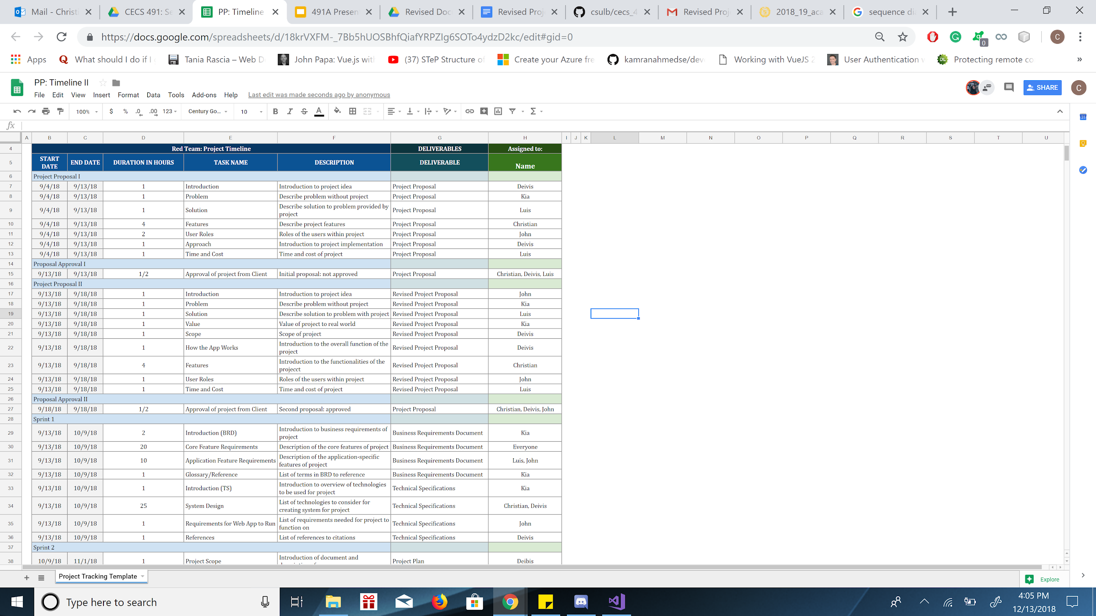

# 

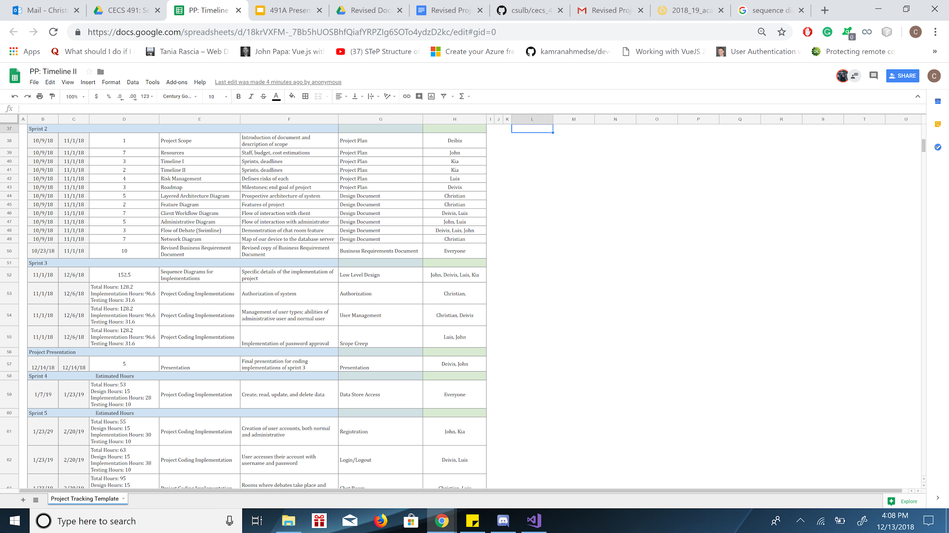

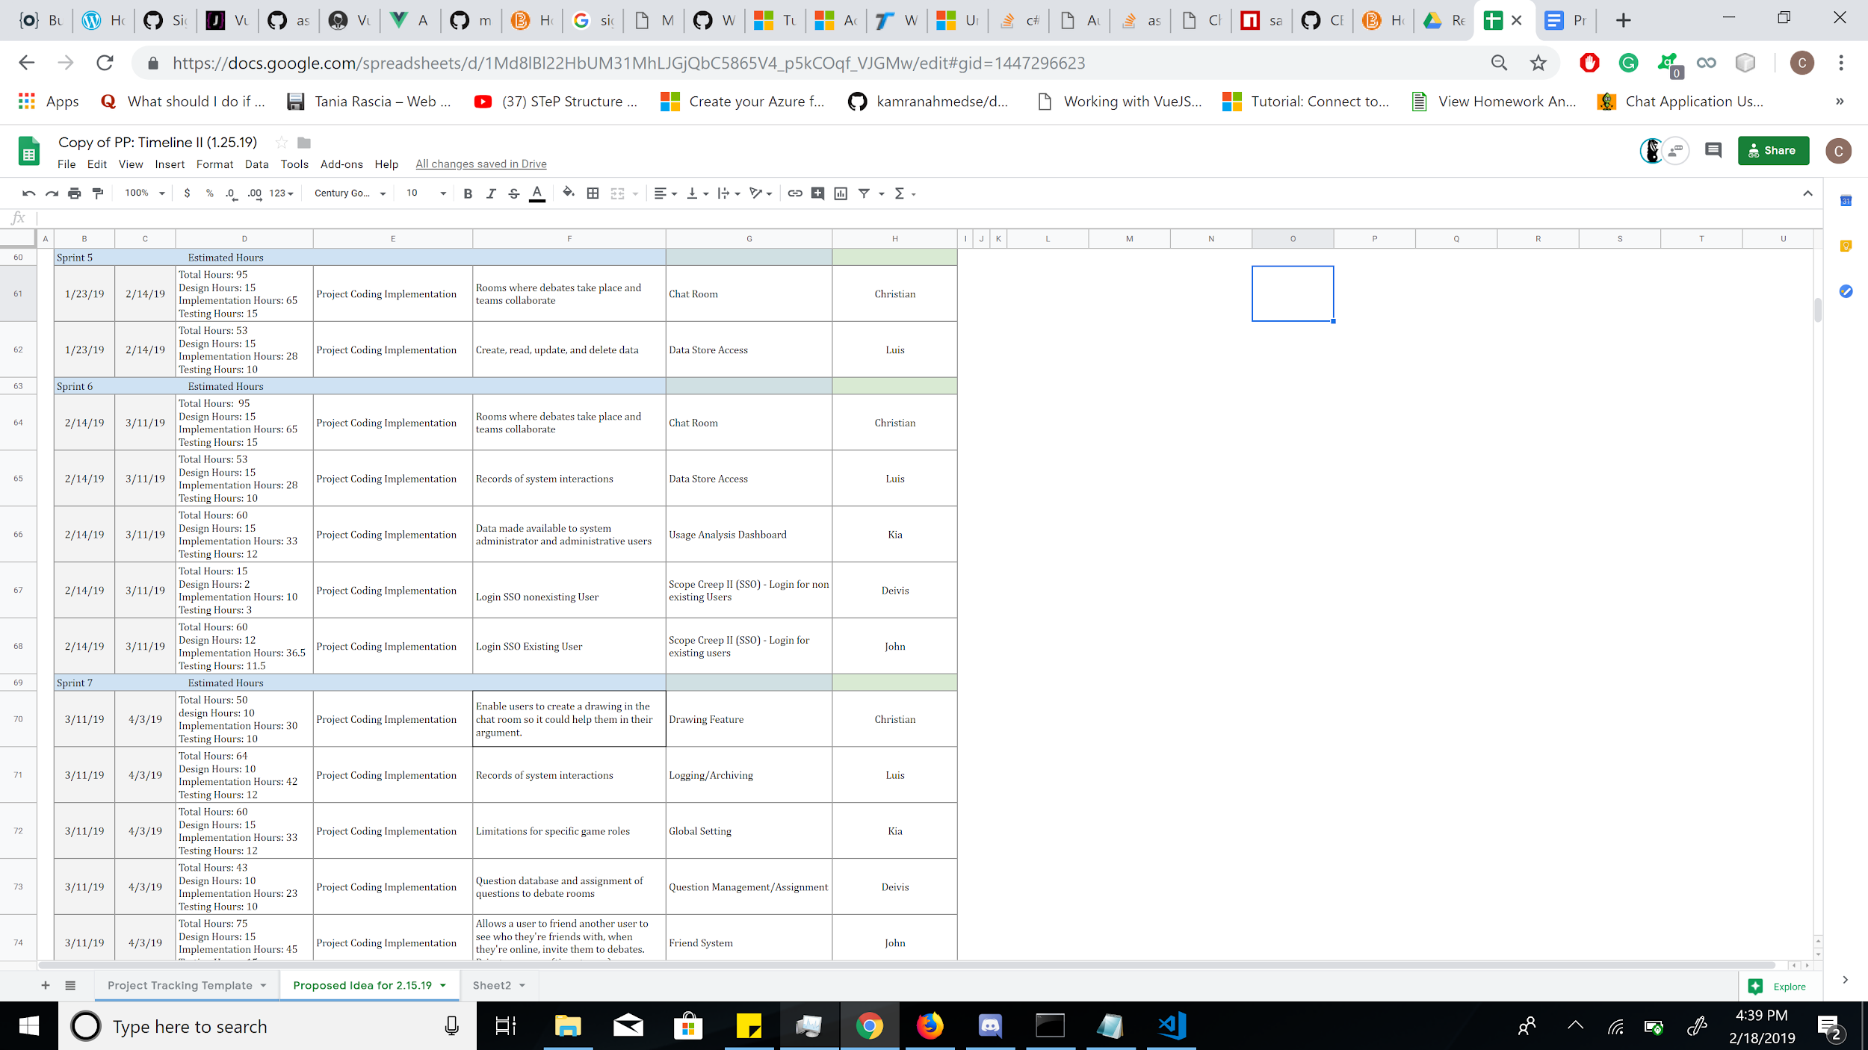

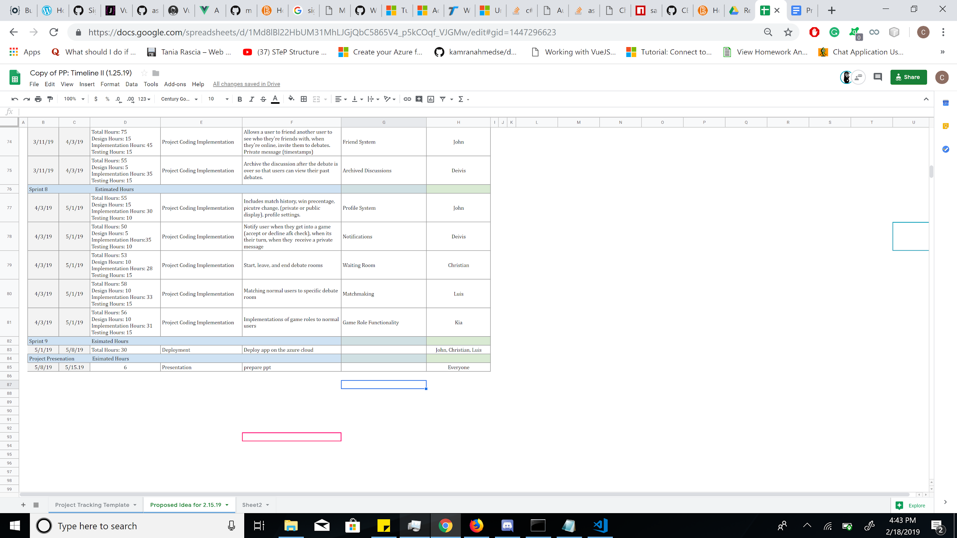

# Roadmap

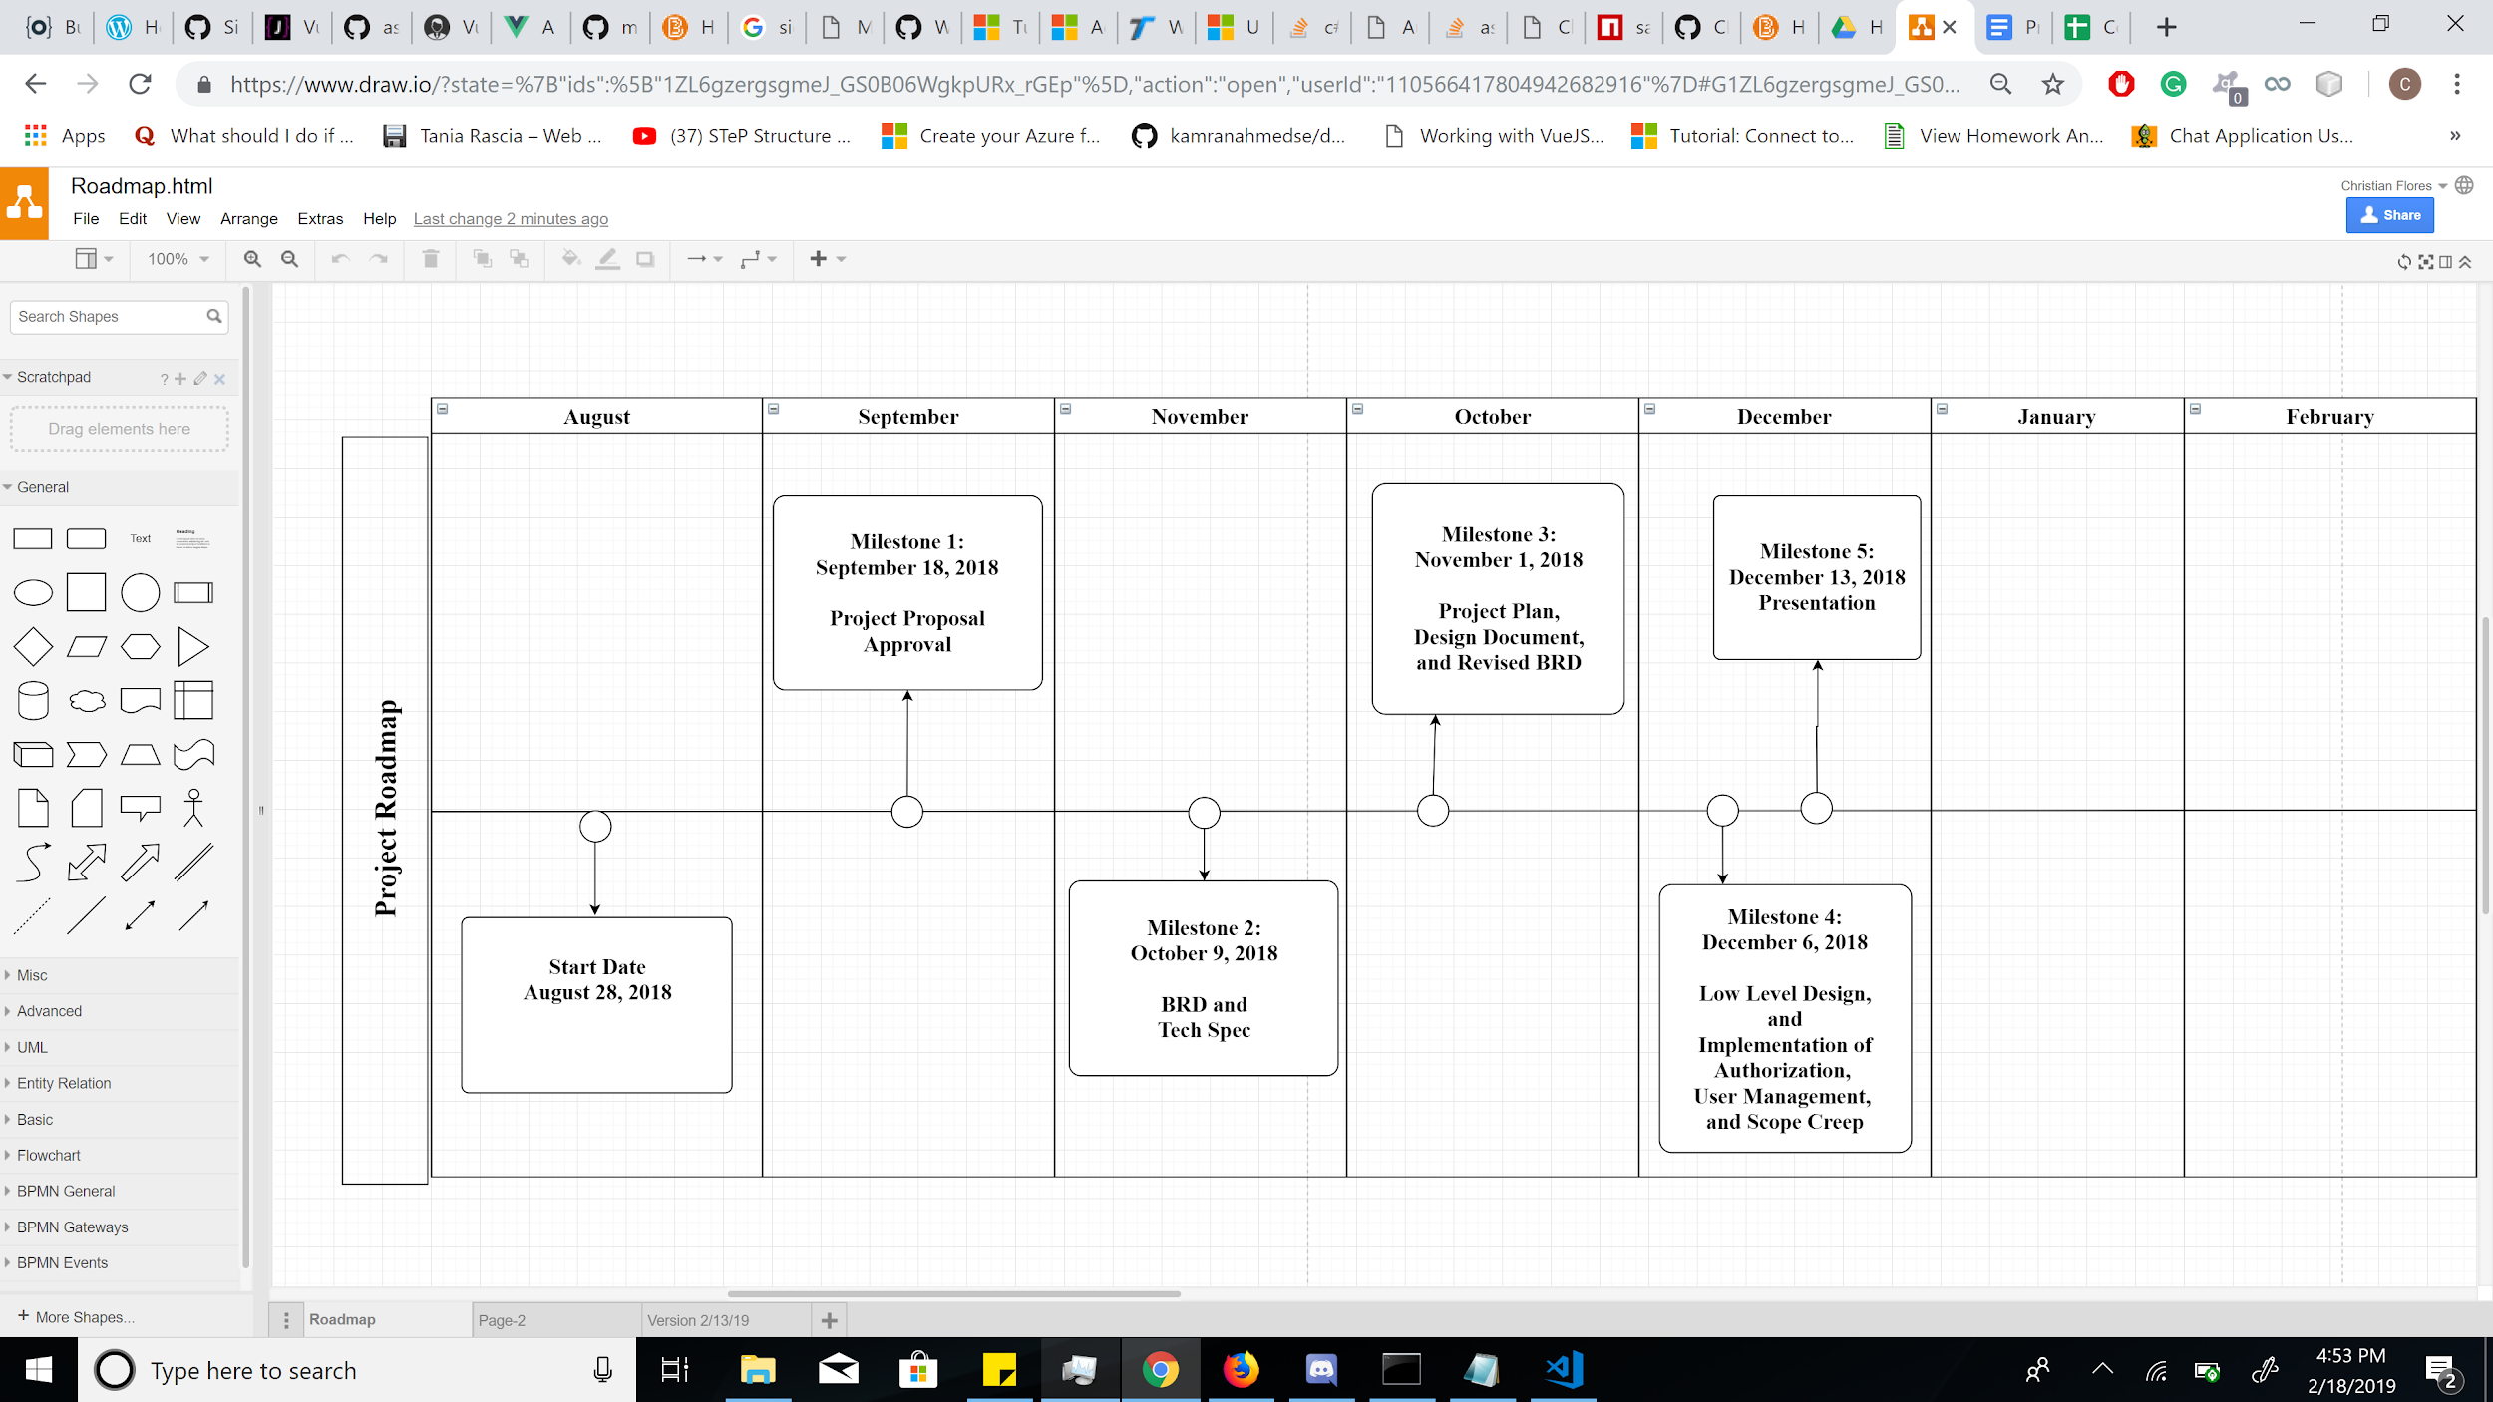

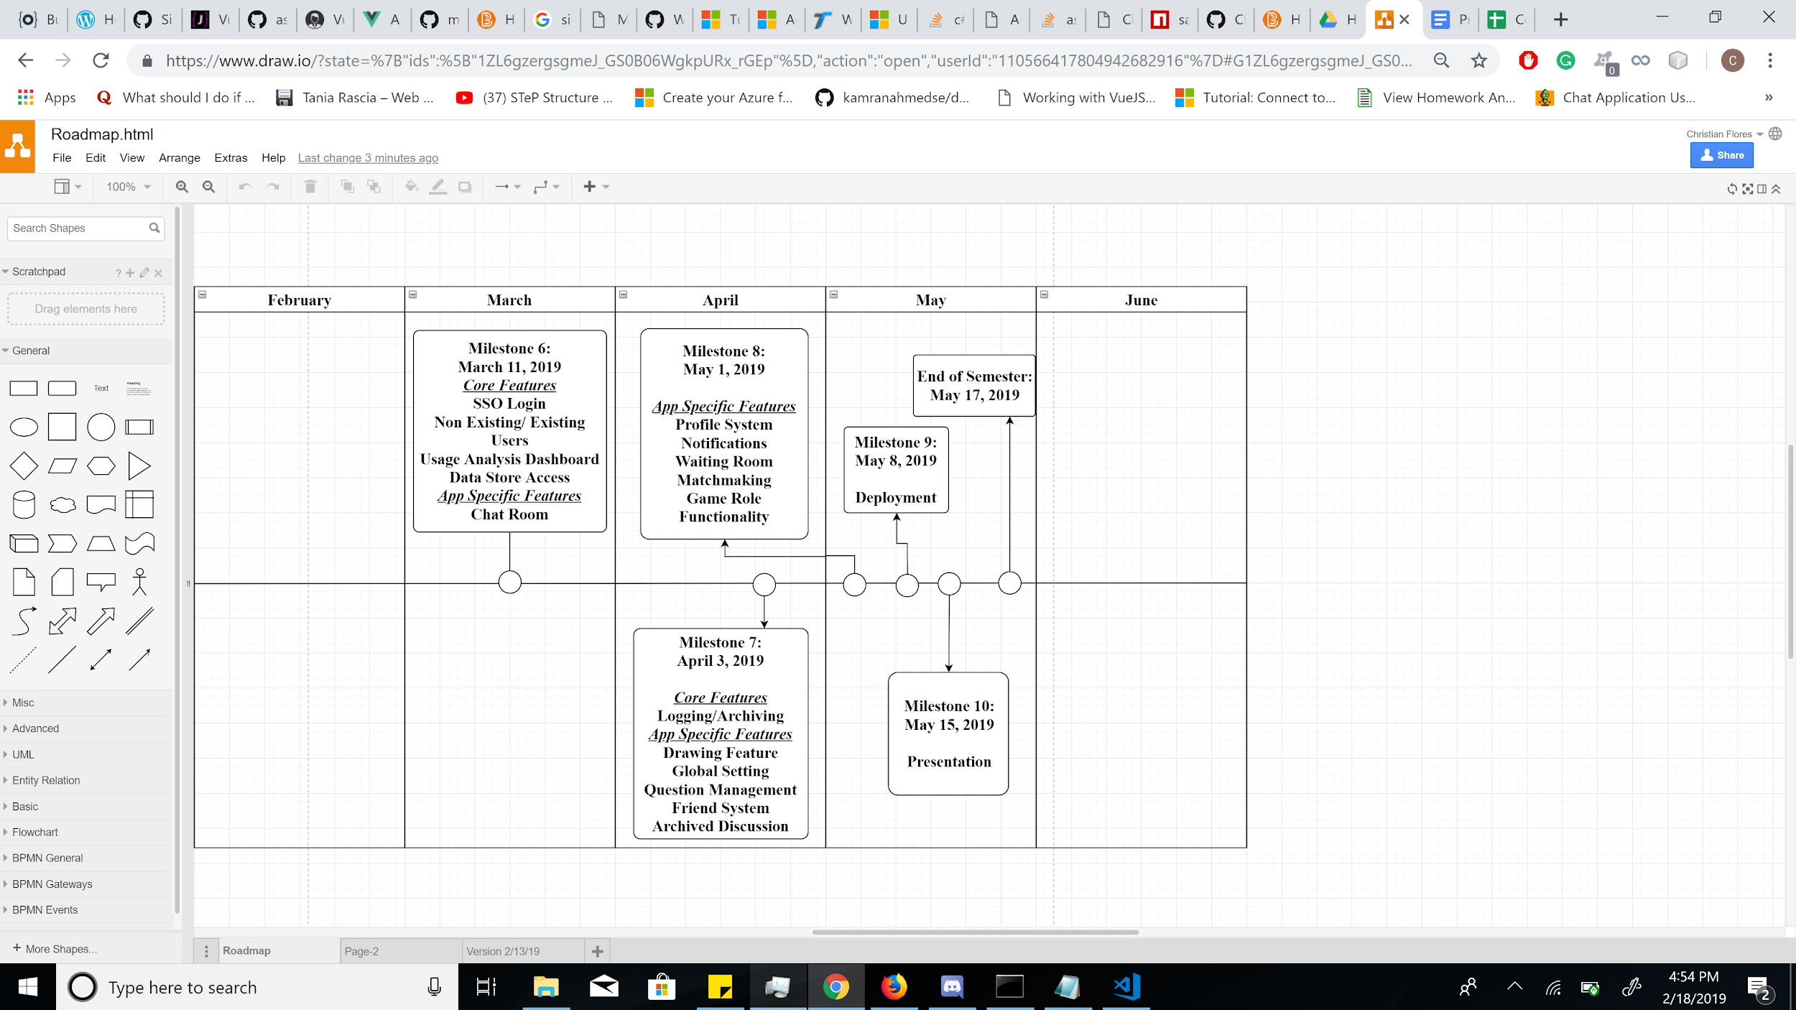

**Risk Management:**

1. A risk associated with our project is our team falling behind schedule. There is a possibility that due to our teams inexperience with the technologies that we are using in our project will result in us being unable to complete all system features on time. We could also fall behind as a result of unforeseen circumstances, such as the loss of a team member, a team member becoming unable to work due to illness, or a natural disaster. The possibility that this occurs is high and it would have a major impact. We would mitigate this risk by keeping track of our progress and knowing how much time we have to complete a feature before we fall behind. We will also prioritize higher priority features if we do fall behind. Our project cannot ever fall two features behind. We are willing to drop global settings and simplify the waiting room. If our team ever falls more than two features behind, then the project will be considered a failure.
2. Another risk associate with the project is that our team goes over budget. It is possible that our team underestimated the cost of our project or that some unforeseen circumstances cause our project’s cost to increase. There is a medium chance of this happening. If this were to happen then our group, our team has already attempted to mitigate this by including a miscellaneous cost section in our original budget. However, it is possible that our project still goes over budget and in this situation, we cannot ever allow our budget to increase over 50% of our original budget. If this were to occur, then our project would not have the funds to be finished.
3. A third possible risk is that our team overestimated our time cost benefits and that we get ahead of schedule. The chances of this occurring are low. Our team would mitigate this risk by keeping track of our progress and if we get ahead of schedule during a sprint, we would move onto the next highest priority feature that we would be able to finish within the timeframe of that sprint. If we actually finish the project ahead of schedule, then our group would add an additional feature not originally included with the project plan.